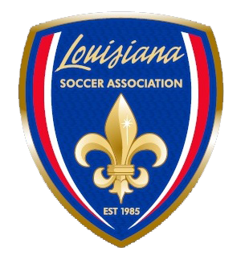

LOUISIANA SOCCER ASSOCIATION

STATE COUNCIL MEETING
July 21, 2024
Embassy Suites

AGENDA

1. Call to Order
2. Roll Call
3. Credentials Report
4. Reading of Minutes and Acceptance
5. Reports
- Youth Soccer Coordinator
- Adult Coordinator
- Social Media Update
- Coaching Education Update
- ODP Update
- LSA Office Update

6. Presentation and Approval of Budget
7. New Business
- Consideration of proposed Amendments to LSA Policy
- LA Force Appeal
8. Elections
- VICE PRESIDENTS – CHAD VIDRINE (Incumbent - Unopposed)
- YOUTH SOCCER COORDINATOR -
- MEMBER-AT-LARGE – SMALL CLUB -
- MEMBER AT LARGE – EVEN YEAR -

9. For the Good of the Game
10. Adjournment

